

[INPUT THE NAME OF THE CAPSTONE SYSTEM]

In Partial Fulfillment of the Requirements in
INFORMATION TECHNOLOGY
SS7 – Special Project

Under the supervision of
[Insert SS7-Instructor Complete Name]

Submitted by:
[Member 1]
[Member 2]
[Member 3]

March 2024
Introduction

Guide:
- Font size: 12
- Font style: Arial
- Spacing
  - After: 8 pt
  - Line Spacing: Multiple
  - At: 1.08
  - Don’t add space between paragraphs of the same style.: Checked
Insert your Introduction here.
In every paragraph must be indented.

Example:
The Human Resource Department or Personnel Department of an Agency or Company maintains a file for individual employees. This file contains all official documents and personnel actions pertaining to a particular employee from the start of employment until the employee leaves the Company. This is known as the 201 File.

Background of the Study

Guide:
- Font size: 12
- Font style: Arial
- Spacing
  - After: 8 pt
  - Line Spacing: Multiple
  - At: 1.08
  - Don’t add space between paragraphs of the same style.: Checked
Insert your Introduction here.
In every paragraph must be indented.

Example:
The Human Resource Department or Personnel Department of an Agency or Company maintains a file for individual employees. This file contains all official documents and personnel actions pertaining to a particular employee from the start of employment until the employee leaves the Company. This is known as the 201 File.

Purposes and Objectives

Guide:
- Font size: 12
- Font style: Arial
- Spacing
  - After: 8 pt
  - Line Spacing: Multiple
  - At: 1.08
  - Don’t add space between paragraphs of the same style.: Checked
Insert your Purposes and Objectives
In every paragraph must be indented.

Example:
The Human Resource Department or Personnel Department of an Agency or Company maintains a file for individual employees. This file contains all official documents and personnel actions pertaining to a particular employee from the start of employment until the employee leaves the Company. This is known as the 201 File.

Context Diagram

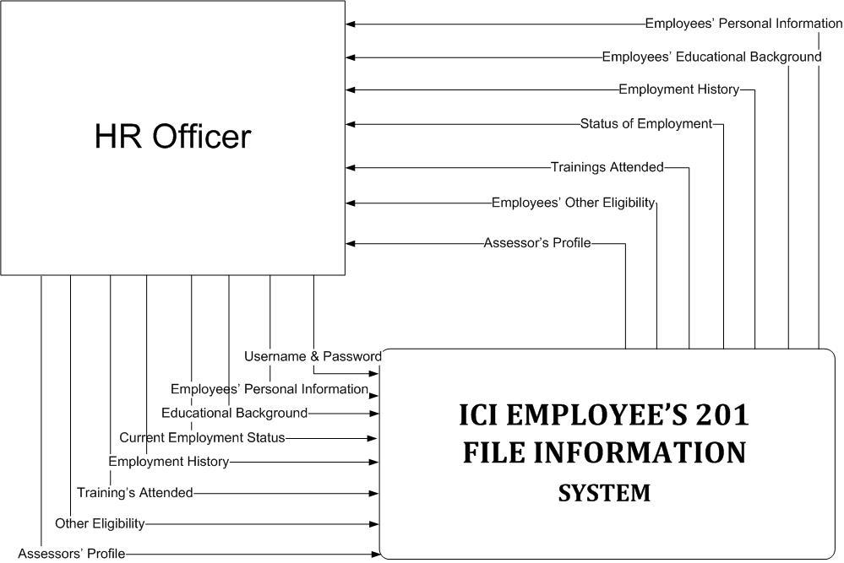

Users Description

Guide:
- 1 user per page, for example: there are 4 users in the system, then it will be 4 pages for the description. continue each user description per page
User Description: Staff
Target User Group: A 22-year-old staff in Metro Manila
Technical Skills: Basic Computer Skills
Domain Knowledge: Deep understanding of local community needs and concerns, familiar with barangay regulations and procedures.
User Needs:
- Needs tools to create, edit, and store documents easily (e.g., Word, Google Docs, and spreadsheets).
- Needs a simple way to organize files and documents, both locally and in cloud storage (e.g., Google Drive, Dropbox)
- Needs to input, track, and update basic data in spreadsheets (e.g., using Excel or Google Sheets).
- .Needs support for solving minor technical issues, such as dealing with slow computers, software crashes, or basic internet connectivity problems.
- Needs basic knowledge of using search engines (e.g., Google) to find relevant information quickly.
Pain Points:
- Feels frustrated when adapting to new software, tools, or platforms introduced by the workplace, particularly if the changes are frequent or not well-explained.
- Struggles with understanding and using advanced features in complex software programs (e.g., advanced Excel formulas, CRM systems, or design tools).
- Feels frustrated when adapting to new software, tools, or platforms introduced by the workplace, particularly if the changes are frequent or not well-explained.
- Prefers traditional communication methods (e.g., face-to-face or phone) because they are more comfortable than using digital tools like email or messaging apps.
Systems Description

This system aims to streamline the management and tracking of technical tools and equipment used in schools. It helps schools avoid lost or misplaced items, ensure proper maintenance, and optimize resource allocation.
Components:
- Inventory Database: Needs an easy-to-use system for entering new inventory items (e.g., product name, quantity, location, and price) without complex data entry forms or advanced software features
- Check-in/Check-out System: Needs automated notifications (e.g., reminder emails for check-out time or overdue items) to help keep track of check-ins and check-outs.
- Maintenance Management: Needs a straightforward way to track the status of maintenance tasks (e.g., pending, in-progress, completed).
- Reporting Module: Needs an easy way to schedule recurring reports (e.g., daily sales report) so that they are automatically generated and emailed at set times.
Operations:
- Adding new equipment: Needs an easy-to-use system to enter essential details of new equipment (e.g., equipment name, model, serial number, location, and department).
- Borrowing/returning: Needs an easy-to-navigate system to record when equipment is borrowed, including simple fields like the borrower’s name, equipment details and the borrow date. Requires the ability to mark the equipment as returned and update its availability in the system automatically.
- Scheduling maintenance: Needs an easy-to-use system to schedule routine maintenance tasks (e.g., equipment servicing, HVAC checks, or facility inspections) with minimal effort.
- Generating reports: Needs a simple, intuitive interface to generate reports with minimal steps and complexity.

Benefits:
- Reduced lost/misplaced items: Needs a simple system to track the location and status of items (e.g., office supplies, equipment, or assets) so they can be easily found when needed.
- Improved maintenance: Needs an easy-to-use system to schedule and track routine maintenance tasks, such as equipment servicing or facility checks, with minimal steps.
- Optimized resource allocation: Identify under/overutilized equipment.
- Increased accountability: Track who borrows and returns items.
- Time savings: Automate tasks and streamline workflows.

Scope and Limitation

Guide:
- Font size: 12
- Font style: Arial
- Spacing
  - After: 8 pt
  - Line Spacing: Multiple
  - At: 1.08
  - Don’t add space between paragraphs of the same style.: Checked
Insert your Scope and Limitation
In every paragraph must be indented.

Example:
The 201 file Information System will cover the employees’ information of ICI. A database is provided to hold data and files such as:
- Employees’ Personal Information– information of an employee, such as where the employee lives, their complete name, gender, civil status, date of birth, contact numbers & e-mail addresses.
- Educational Background–educational attainments of the employee.
- Current Employment Status – where they currently work, the status of their employment (whether part-time, permanent, casual, contractual or job order), and also their eligibility to attain their work.
- Employment History –information about the employees work experience, the cause why the employee left his/her former job, and the date when their employment ended.
- Trainings Attended –the trainings that the employees have attended, the date and where the training happened.
- Other Eligibility – refers to the name of qualification obtained by the trainee according to the four (4) qualification levels defined in the PTQF, the sector where the qualification obtained is included, the date the trainer was certified, date when the certificate will expire and licenses acquired.
- Assessor’s Profile -refers to the title of the qualification the trainer is accredited for assessment.
This system is specifically designed for the adoption of computerized 201 file information system and it is only accessible by a Human Resource Officer. However there are some Employees’ information which are not part of the system like:
- Performance Evaluation
- Medical History
- Derogatory Reports
- International Training
- Leave of Absence & Payroll

Operational Manual

Entity-Relationship Diagram
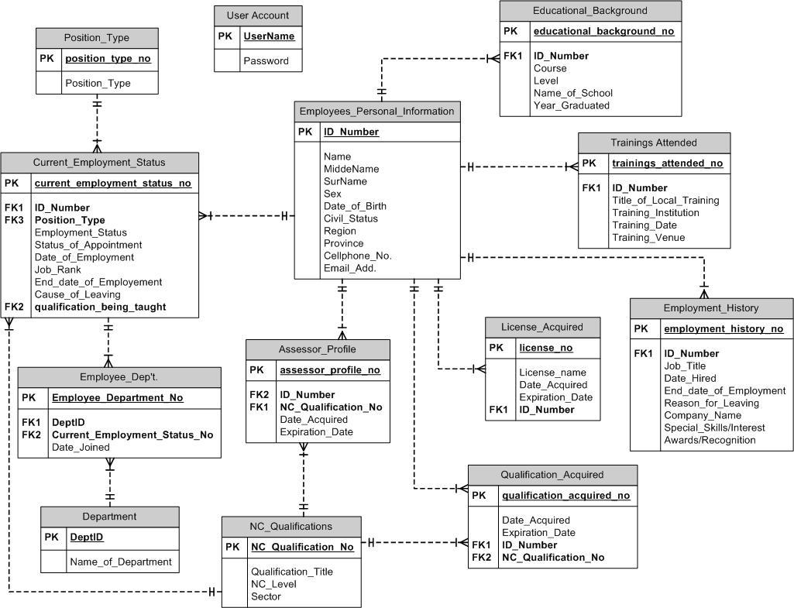
Use Case Diagram

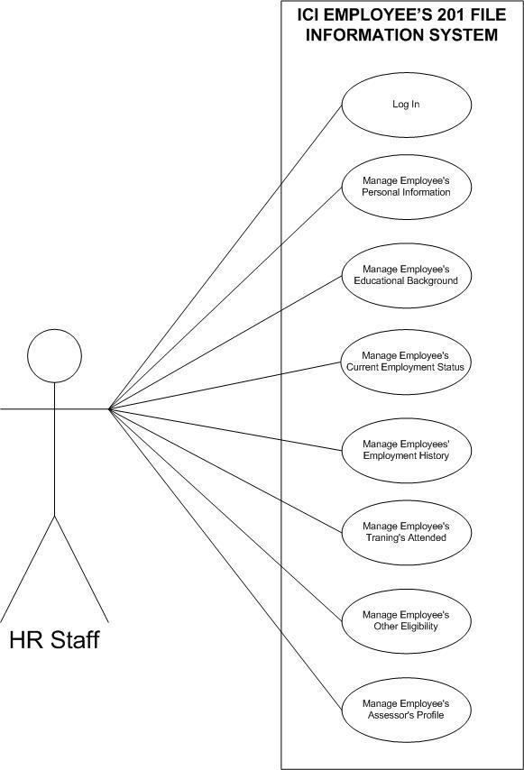
Use Case Specification: Login

Guide:
- Font size: 12
- Font style: Arial
- Spacing
  - After: 8 pt
  - Line Spacing: Multiple
  - At: 1.08
  - Don’t add space between paragraphs of the same style.: Checked
Example:
Brief Description
This use case allows the user to enter his/her username and password.

Flow of Events
  - Basic Flow
This use case starts when the user wants to login to the system.
    - The system asks the user to enter his/her username and password.
    - The user enters his/her username and password.
    - The system validates the entries and logs the user to the system.

  - Alternative Flow(s)
Invalid username and/or password.
    - The system will display an error message.
    - The user can choose to either return to the beginning of the Basic Flow or cancel the login, which the use case ends.

- Precondition
The user must be registered to the system before he/she can login.

- Post-conditions
If the use case is successful, user is now logged into the system. If not, the system state is unchanged.

Activity Diagram: Login

Example:
